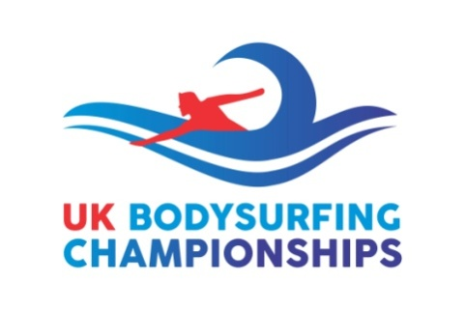
Schedule: UK Bodysurfing Championships 2019
Saturday 7th September
- 0800-0830 Set up tents and locate flags
- 0830 – Bodysurfers Check in
- 0900 – Heat 1 Open (20 mins)
- 0920 – Heat 2 Open (20 mins)
- 0940 – Heat 3 Open (20 mins)
- 1000 – Heat 4 Open (20 mins)
- 1020 – Heat 1 Handboard (20 mins)
- 1040 – Heat 2 Handboard (20 mins)
- 1100 – Heat 3 Handboard (20 mins)
- 1120 – Heat 4 Handboard (20 mins) - HT 1210
- 1140 – Semi-Final 1 Open (20 mins)
- 1200 – Semi-Final 2 Open (20 mins)
- 1220 – Semi-Final 1 Handboard (20 mins)
- 1240 – Semi-Final 2 Handboard (20 mins)
- 1330 – Ladies Open Final (20 mins)
- 1400 – Men’s Open Final (20 mins)
- 1430 – Men’s Handboard Final (20 mins)
- 1500 – Initial Prize Giving for 1st, 2nd, 3rd and 4th places – all events (on balcony)
- 1600-1800 - Chill Out in Fistral Beach Bar (including all main prize giving)

UK Bodysurfing Championships C.I.C./UK Bodysurfing Association C.I.C.
5B College Road, Newton Abbot, Devon TQ12 1EF
Tel :-M. 07816 385326
Email:- bodenham3@btinternet.com
www.body-surfing.co.uk/uk-bodysurfing-championships-c-i-c

Schedule: (back up day)
Sunday 8th September
- 0800-0830 Set up tents and locate flags
- 0830 – Bodysurfers Check in
- 0900 – Heat 1 Open (20 mins)
- 0920 – Heat 2 Open (20 mins)
- 0940 – Heat 3 Open (20 mins)
- 1000 – Heat 4 Open (20 mins)
- 1020 – Heat 1 Handboard (20 mins)
- 1040 – Heat 2 Handboard (20 mins)
- 1100 – Heat 3 Handboard (20 mins)
- 1120 – Heat 4 Handboard (20 mins)
- 1140 – Semi-Final 1 Open (20 mins)
- 1200 – Semi-Final 2 Open (20 mins)
- 1220 – Semi-Final 1 Handboard (20 mins)
- 1240 – Semi-Final 2 Handboard (20 mins)
- 1330 – Ladies Open Final (20 mins) - HT 1337
- 1400 – Men’s Open Final (20 mins)
- 1430 – Men’s Handboard Final (20 mins)
- 1500 – Initial Prize Giving for 1st, 2nd, 3rd and 4th places – all events (on balcony)
- 1600-1800 All main prize giving (possibly in Fistral Beach Bar)

UK Bodysurfing Championships C.I.C./UK Bodysurfing Association C.I.C.
5B College Road, Newton Abbot, Devon TQ12 1EF
Tel :-M. 07816 385326
Email:- bodenham3@btinternet.com
www.body-surfing.co.uk/uk-bodysurfing-championships-c-i-c

