UK Bodysurfing Championships 2019 – Men’s Handboard
Heat 1 Semi-final 1
1 | RED | OWEN JACKA (Cornwall) | 2 |  | 1 | RED | GREG STRANGE (Surrey) | 3
2 | BLUE | GARY SANDERSON (Kent) | 4 |  | 2 | BLUE | THEO PEPLER (Scotland) | 1
3 | YELLOW | GREG STRANGE (Surrey) | 1 |  | 3 | YELLOW | OWEN JACKA (Cornwall) | 2
4 | GREEN | THOMAS ARROW (Cornwall) | 3 |  | 4 | GREEN | LEWIS DAY (Dorset) | 4
Heat 2 Semi-final 2
1 | RED | LOIC DOISON (France) | 4 |  | 1 | RED | WAYNE SHEPPARD (Cornwall) | 4
2 | BLUE | THEO PEPLER (Scotland) | 1 |  | 2 | BLUE | DAVID SMITH (Devon) | 1
3 | YELLOW | LEWIS DAY (Dorset) | 2 |  | 3 | YELLOW | ANDREW OSBORNE (Australia) | 2
4 | GREEN | JAMIE ELLIOT (Cornwall) | 3 |  | 4 | GREEN | DAMIEN NICHOLSON (Cornwall) | 3
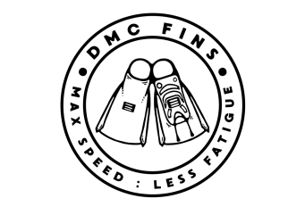
Heat 3
1 | RED | ANDREW OSBORNE (Australia) | 2
2 | BLUE | WAYNE SHEPPARD (Cornwall) | 1
3 | YELLOW | SIMON FUNNELL (Wiltshire) | 3
4 | GREEN |  | 4

Heat 4 Final
1 | RED | DAVID SMITH (Devon) | 1 |  | 1 | RED | OWEN JACKA (Cornwall) | 4
2 | BLUE | DAMIEN NICHOLSON (Cornwall) | 2 |  | 2 | BLUE | DAVID SMITH (Devon) | 1
3 | YELLOW | DONALD ASPREY (Hong Kong) | 3 |  | 3 | YELLOW | THEO PEPLER (Scotland) | 3
4 | GREEN |  | 4 |  | 4 | GREEN | ANDREW OSBORNE (Australia) | 2

