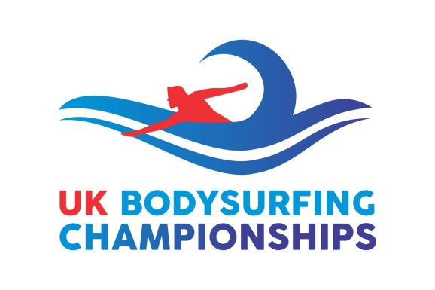
UK Bodysurfing Championships 2019
Entry Form
(All UK entrants must be members of the UK Bodysurfing Association CIC to compete)
UK entrants can go to www.body-surfing.co.uk/membership-join to become a member first. (Memberships:- £15 for adults/£10 for Juniors (under 18).
(Nearly all memberships have lapsed:- We have introduced this year a new annual membership scheme to coincide with these Championships, whereby all members obtain new memberships (valid now, not expiring until 31st August 2020)).
Entry Fees for Championships:-
- Overseas competitors - £45 per event (£80 if entering two events)
- Members - £45 per event (£80 if entering two events)
Name _____________________________________________ M/F_________________
Open Event_____________ Handboard event_____________ Ladies event __________
Address ________________________________________________________________
____________________________________________ Post Code __________________
Email _______________________________________ Telephone no _______________
Payment Details:-
BACS:-
UK Bodysurfing Championships C.I.C. (please include your name in reference)
Sort Code 30-62-62
Account No 22465968

Cheques to:-
UK Bodysurfing Championships C.I.C.
5B College Road
Newton Abbot, DEVON. TQ12 1EF

Please send completed forms to bodysurfing@body-surfing.co.uk

